# Introduction

This app is a means by which student attendance can be taken. It improves an existing manual process, subject to inefficiencies. An online database serves as its center, allowing multiple instances of the app to run on various devices without causing duplication. The system makes use of the barcodes on student ID cards, integrating a barcode scanner for quick, accurate roll records.

## Goals

* Quickly scan student ID’s
* Update records for a course
* View records for courses
* Maintain online database, available to multiple users

## System Requirements

* External database service; Firebase.
* Internet access necessary for core functions currently.
* Barcode scanning API; zxing package.
* Administration can access database separately from users.
* App does not allow database administration.

## User Requirements

* Scan barcodes quickly.

# Process Overview

## Main

Users are greeted with this screen upon opening the app. Here they have the option to view existing course records or start scanning attendance for a new instance of a course. Selecting either option brings up the same course list view but tapping on an item will have a different function depending on the initial selection.

## Date

This option causes the course list to be displayed. Tapping on a course displays the dates of classes thus far. Selecting a date brings up the attendance for the course on that date.

## Scan

Selecting “Enroll” also displays the course list. Tapping on a course from this option takes the user to the scanning page. The app accesses the device camera to scan an ID card’s barcode and decode the student ID. Visual confirmation is given for both a scan success and a fail.

# Conceptual Model



# Barcode Scanner

The app makes use of zxing package……………………………

# Online Database

The app makes use of Firebase, an online JSON database. The data is located at <https://enroll.firebaseio.com>. All instances of the app can link to the same database. Any other applications such as administrative software can be implemented to manage the database if needed. Using this database is faster and less resource intensive than a local SQL database.

The data structure is as follows:

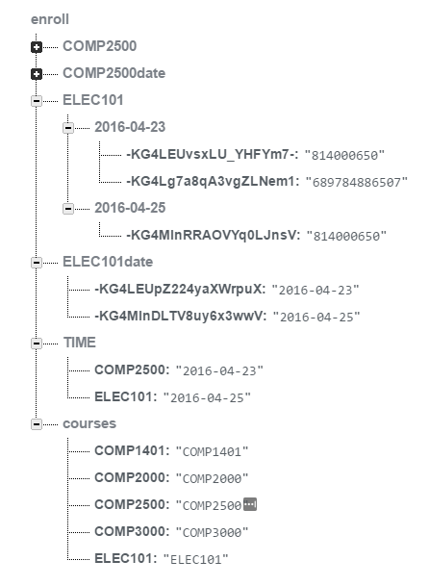“courses” represents the course list. Users select a course, at which point the app pulls the system date and makes a record under “TIME”.

New records are created for each course to represent all the dates of that course. This can be seen under ELEC101date and COMP2500date.

Finally the app makes records for attendance, seen under ELEC101. Each date in this tree has a list of all scanned ID’s for attendance.